

**UNIVERSITY INSTITUTE OF ENGINEERING**

**Department of Computer Science & Engineering**

|  |  |
| --- | --- |
| **Submitted By:                                                                          Submitted To:**  Rahul Kumar (20BCS7081) Er. Nitsha (E13137) | |
| **Subject Name** | Data Mining |
| **Subject Code** | 20CSP_376 |
| **Branch** | CSE |
| **Semester** | 6th |

LAB INDEX

|  |  |  |  |  |  |  |  |
| --- | --- | --- | --- | --- | --- | --- | --- |
| **Sr.No** | **Program** | **Date** | **Evaluation** | | | | **Sign** |
| **LW(12)** | **VV(8)** | **FW(10)** | **Total (30)** |
|  |  |  |  |  |  |  |  |
|  |  |  |  |  |  |  |  |
|  |  |  |  |  |  |  |  |
|  |  |  |  |  |  |  |  |
|  |  |  |  |  |  |  |  |
|  |  |  |  |  |  |  |  |
|  |  |  |  |  |  |  |  |
|  |  |  |  |  |  |  |  |
|  |  |  |  |  |  |  |  |

**Experiment 1.2**

**Student Name: Rahul Kumar UID: 20BCS7081**

**Branch: BE-CSE Section/Group:20BCS_DM-716 B**

**Semester: 6 Date of Performance: 22 Feb 2023**

**Subject Name: DM LAB Subject Code: 20CSP_376**

**AIM :-**

**Using the pre-functions of r programming languages on the data frame of .arff file.**

**Code:-**

library(RWeka)

setwd("C:\\Users\\RAHUL KUMAR\\Desktop\\r")

getwd()

Name <- c("Rahul","rohit","Mohan","sohan","Ajay")

Uid <- c("20BCS7081","20BCS5009","20BCS5542","20BCS9948","20BCS5097")

average_sleep_hrs <- c(10,2,9,11,20)

Student <- data.frame(Name,Uid,average_sleep_hrs)

print(Student)

write.arff(Student,file="Student.arff")

N=read.arff("Student.arff")

print(N)

print(head(N,2))

dim(N)

names(N)

print(N["Name"])

max(N["average_sleep_hrs"])

min(N["average_sleep_hrs"])

sum(N["average_sleep_hrs"])

mean(N["average_sleep_hrs"])

median(N["average_sleep_hrs"])

sd(N["average_sleep_hrs"])

summary(N)

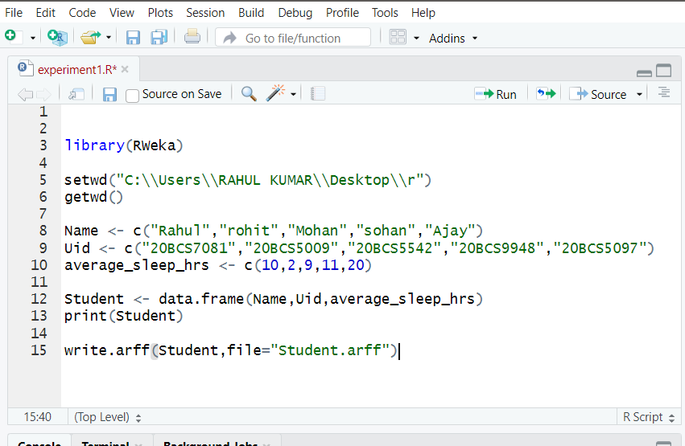

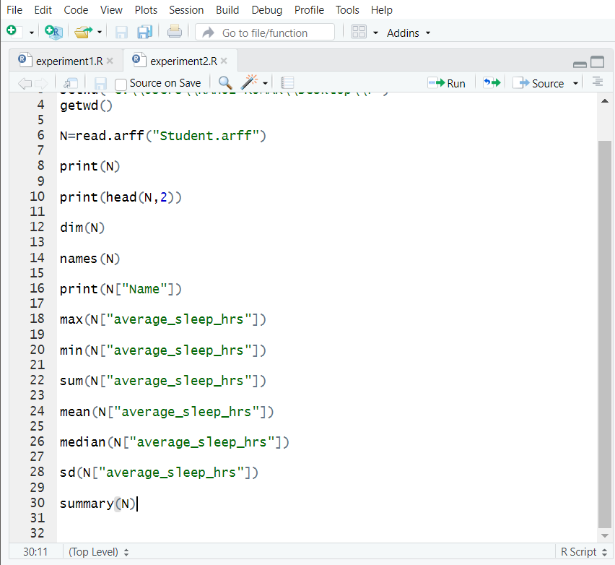

**Data:-**

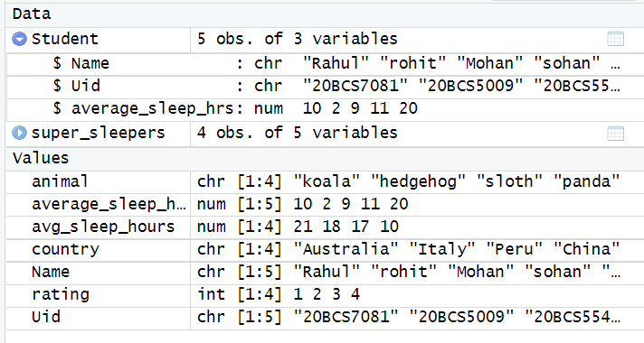

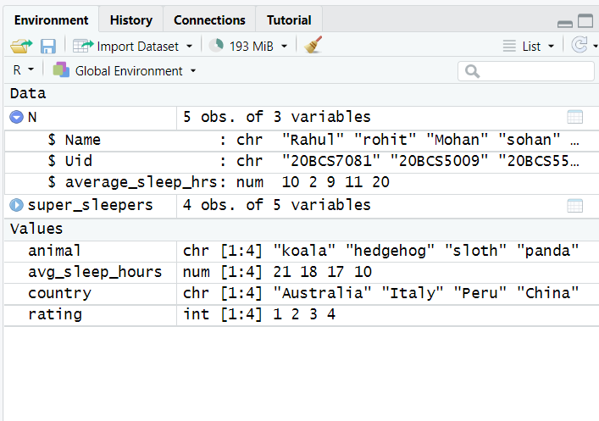

Output:-

